* **LDR (Light Dependent Resistor)** as the name states is a special type of resistor that works on the photoconductivity principle means that resistance changes according to the intensity of light. Its resistance decreases with an increase in the intensity of light.

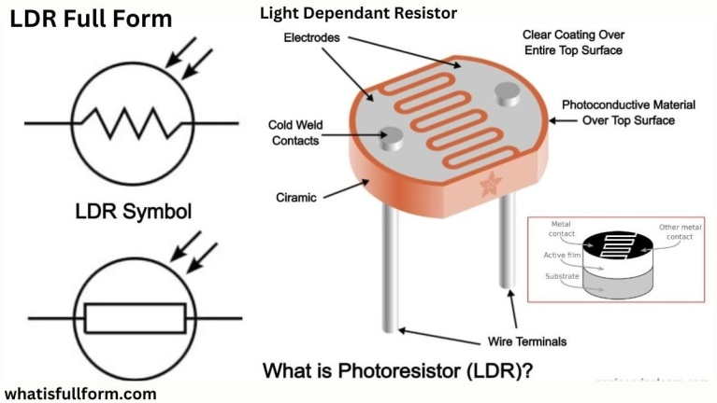

It is often used as a light sensor, light meter, Automatic street light, and in areas where we need to have light sensitivity. LDR is also known as a Light Sensor. LDR are usually available in 5mm, 8mm, 12mm, and 25mm dimensions

An LDR sensor, or Light Dependent Resistor sensor, is commonly used on robots to detect changes in light intensity. This type of sensor works by changing its electrical resistance based on the amount of light that it's exposed to.

